Homework for Chapter 7: Drawing Causal Diagrams

1. You are making a simplified causal diagram to represent the data generating process of viewership for a TV show. Which of the following is true?
   1. **The diagram should include a variable for “number of celebrities in the cast” *this one makes the most sense. B is wrong because that should be a single variable, C is bullshit because you can find out show budgets and if you couldn’t I am sure there is some sort of proxy measurement, and then D is just a very odd and random thing to say lol.***
   2. The diagram should contain one variable for “show airs in the evening” and another for “show doesn’t air in the evening”
   3. The diagram should not contain a variable for “show budget” because budgets are often secret and the researcher can’t measure them
   4. The diagram should contain the variable “review score in the Jefferson Weekly,” which is the newspaper published by the students at Jefferson High School, with a readership of about 120 people.
2. Draw a causal diagram for the research question “do long shift hours make doctors give lower-quality care?” that incorporates the following features (and only the following features):
   1. Long shift hours affect both how tired doctors are, and how much experience they have, both of which affect the quality of care
   2. How long shifts are is often decided by the hospital the doctor works at. There are plenty of other things about a given hospital that also affect the quality of care, like its funding level, how crowded it is, and so on
   3. New policies that reduce shift times may be implemented at the same time (with the timing determined by some unobservable change in policy preferences) as other policies that also attempt to improve the quality of care

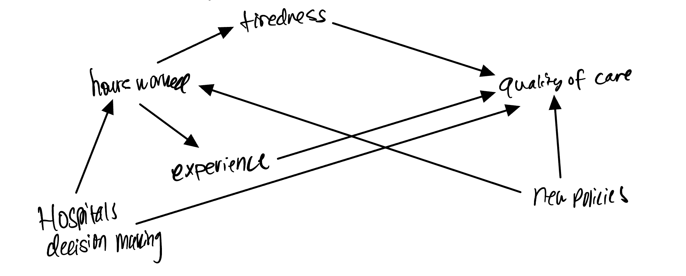

1. Consider this research question: Does the funding level of public schools affect student achievement for students in your country?
   1. What is the treatment and what is the outcome of interest?
      1. **Treatment would be funding amount for public schools and then student achievement is the outcome of interests**
   2. Write down a list of relevant variables.
      1. **School’s location**
      2. **School’s size**
      3. **Demographics of students**
      4. **Demographics of teachers**
      5. **Student to teacher ratio**
      6. **SES**
      7. **Number of students enrolled in “honors” courses**
      8. **Schools funding amount**
      9. **Students’ achievement**
   3. Which of the variables in your list in part b are causes of both treatment and outcome?
      1. **My variables of number of students enrolled in honors courses and SES.**
   4. Why might we want to pay extra attention to the variables listed in part c?
      1. **Because they are plausible confounders for our research q**
   5. Draw a causal diagram of the variables listed in part b.] 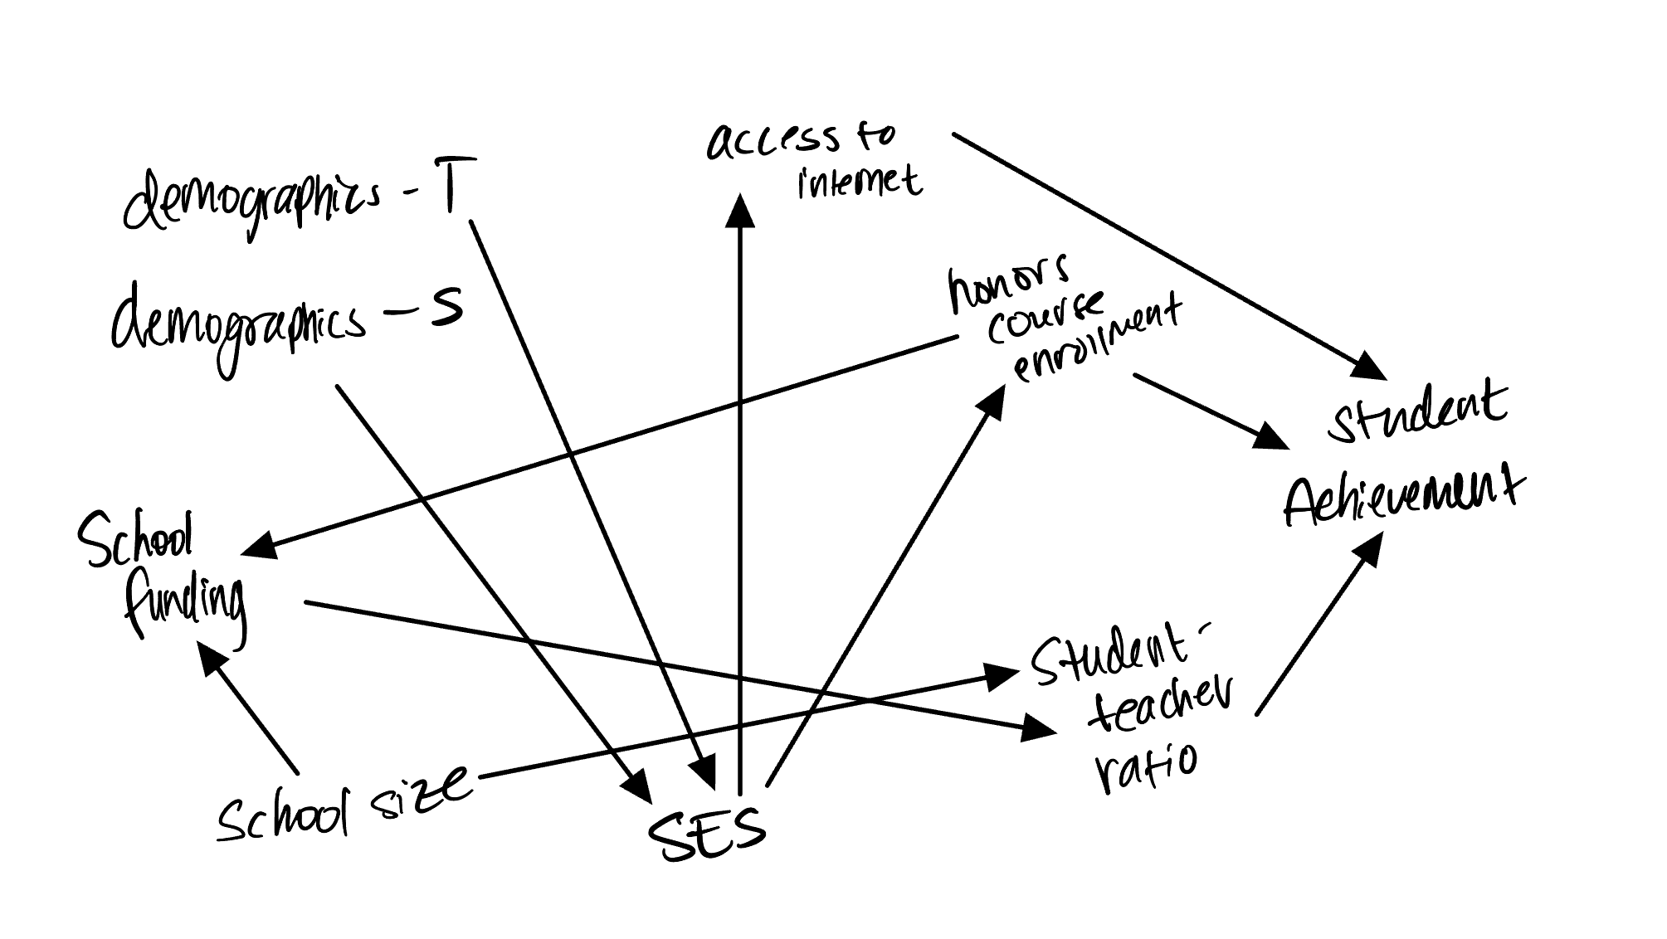
   6. Simplify the diagram from part e.

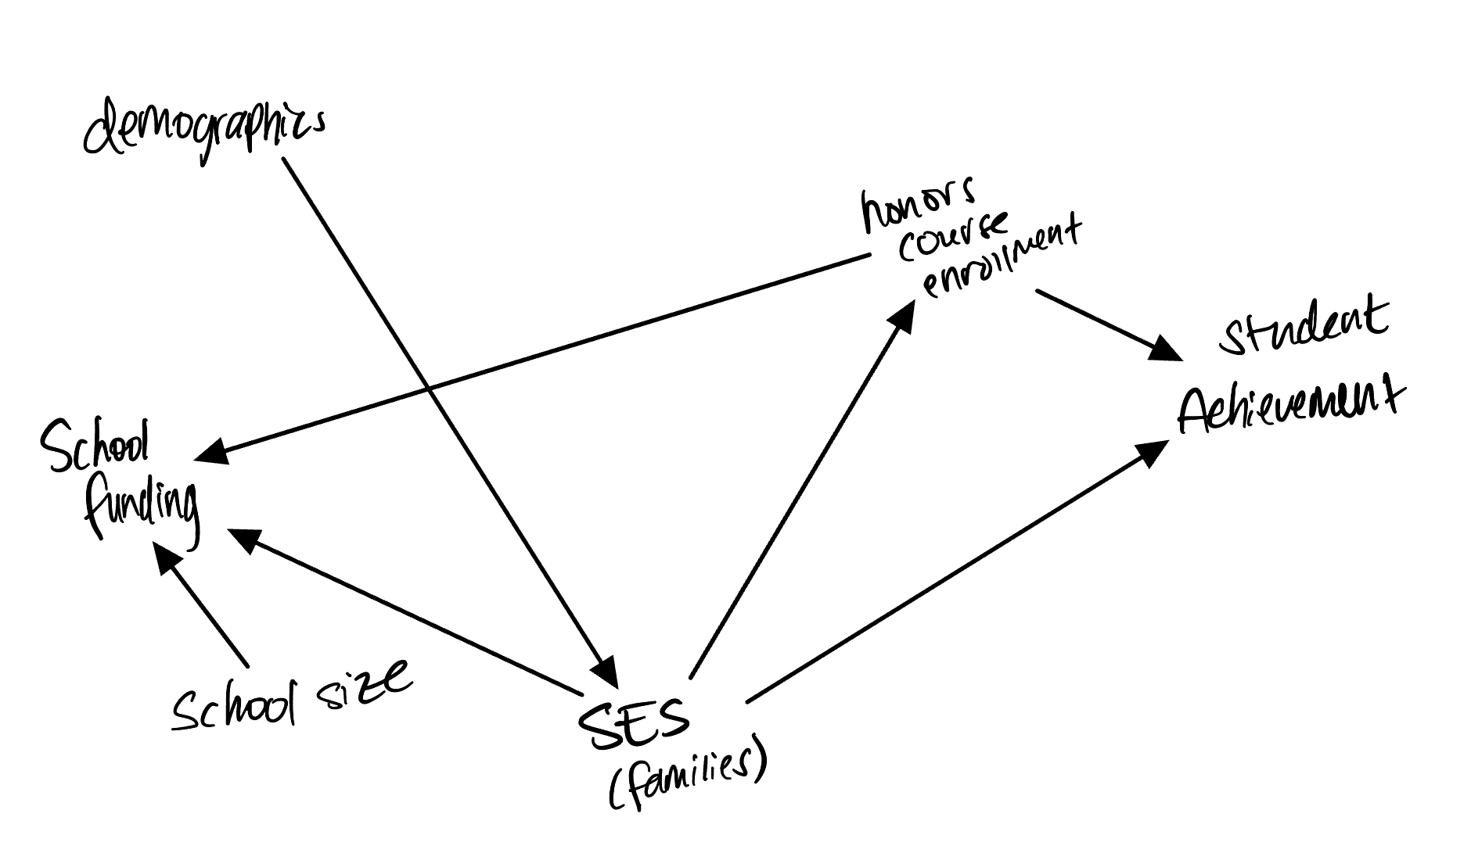

1. Describe the kinds of situations that each of the following could be applied to in order to simplify a causal diagram.
   1. ***Unimportance would be a case in which the variable listed likely has a minimal effect on our outcome variable… hmm a good example would be for example how early the bus arrives to student’s homes which is plausibly related to both school funding and student achievement. Underfunded schools group busses together for the entire district, taking more time and some students must be up much earlier than others, losing sleep. This loss of sleep could then impact their achievement.***
   2. ***Redundancy can be seen pretty easily when two variables have the same arrows going in and out to the same variables in the same direction. Just the way I described it was redundant… A pretty good example of this would be like school size and rurality, different things but so similar for the purposes above it would be redundant to include!***
   3. ***Mediators are besties that just exist as basically a variable to pass through. So for example if we wanted to know if studying causes higher grades studying 🡪 degree of understanding 🡪 grade on exam, degree of understanding is only a mediator and can be removed!***
   4. ***Irrelevance is if a variable is not on the path for treatment and outcome. So it would not need to be included. This would be like including occupational prestige for families, yes this could influence SES and school type, but likely not important for question at hand.***
2. How can a causal diagram be modified so as to avoid cyclic relationships?

***There are two different ways this could be approached: either by considering time as a component to each variable so they can be systematically split OR if it is possible to create randomization of a variable*.**

1. Think of a research question in your field of interest.
   1. What is the cause variable and what is the outcome variable?
      1. ***Causal variable is economic mobility, the outcome variable is life expectancy***
   2. Write down a list of between 5 and 10 relevant variables in the data generating process.
      1. **Gender**
      2. **Racial discrimination**
      3. **Occupational prestige**
      4. **Parents’ SES**
      5. **Childhood SES**
      6. **Health risks**
      7. **Home ownership**
   3. Draw a causal diagram incorporating all the variables from part b.

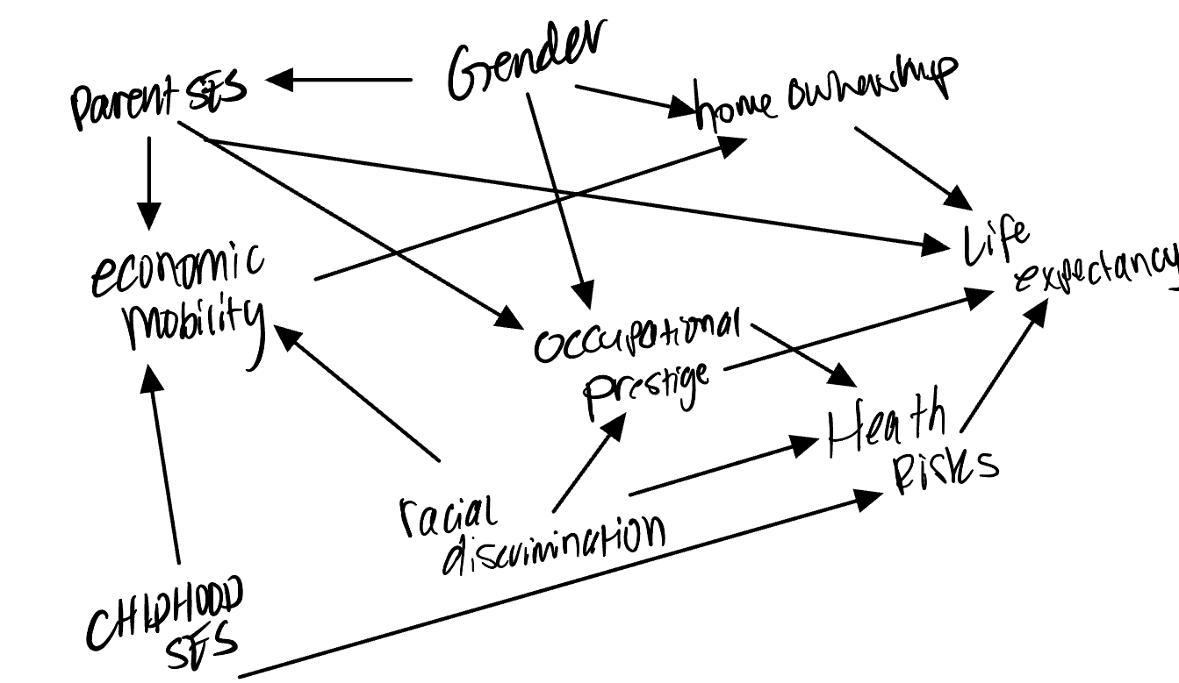

* 1. Stop working on this problem for fifteen minutes and do something else. Then come back, look at your causal diagram from part c again, and describe one bad assumption you think it made, or something it left out.
     1. ***One garbage assumption is that there is a difference with childhood and parent SES. I mean not to mention not specifying SES but ya know. I also think maybe occupational prestige is so conflated that it may really not be needed.***

1. Consider the diagram below. It depicts a cyclical relationship between student achievement and motivation. If students achieve more (i.e., score well on exams), then their motivation goes up, and if their motivation goes up, they achieve more. Change the diagram so that the relationship is not cyclic anymore.  
   

